**CENTURION UNIVERSITY OF TECHNOLOGY AND MANAGEMENTS**



**Assignment 5**

Course Title: System Integration with Dymola

Course Code: CUTM1022 (0-0-2)

**Submitted to:**

***Dr. Sudhansu Kumar Samal***

*Faculty of*

*School of Engineering & Technology, Bhubaneswar*

**Submitted by:**

Name: Kiran Kumar Malik

Registration no: 200301120128

Branch: B-Tech in Computer Science and Engineering’s

Semester: 4th Sem

Section: C

**Experiment No.: 5**

Full-wave Rectifier

**Requirements:**

OpenModelica software

**Procedure:**

Step 1: Open Openmodelica connection editor

Step 2: Click on New Modelica class, give a new Modelica class name, then click on ok

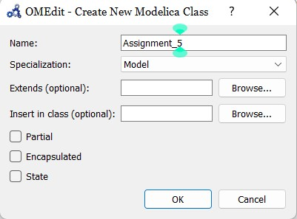

Step 3: Then this type of page will appear

Step 4: Go to Modelica packages, then go to electrical, then analog, then basic, then drag resistor and ground to the modeling field , then choose the constant voltage from source packages.

I connected four diodes in proper way, then connected the connection between diodes and sineVoltage. then the connection between negative terminal of diode to the positive terminal of resistor, then connection between negative terminal of the registor to the positive terminal of diodes, at the end connect the connection between sineVoltage to ground.

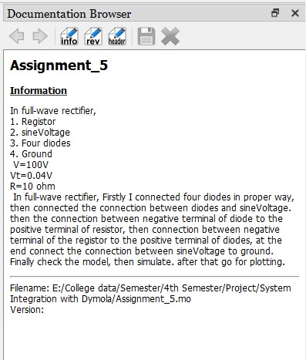Add some information of the modeling

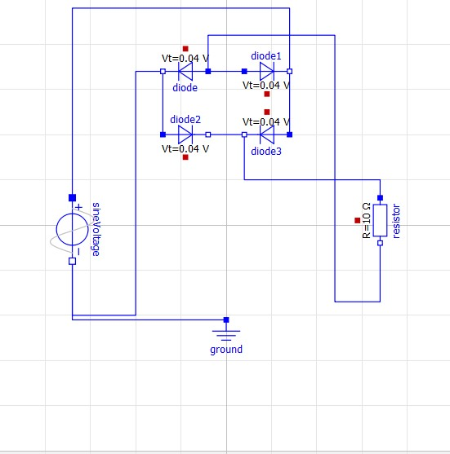

Step 5: After the completion of modeling then save the Modelica file into your pc as .mo extensions, after that go for simulation, when clicking on simulation then compilation occurs, graphical language changes into modelica language.

model Assignment_5

Modelica.Electrical.Analog.Basic.Ground ground annotation(

Placement(visible = true, transformation(origin = {0, -52}, extent = {{-10, -10}, {10, 10}}, rotation = 0)));

Modelica.Electrical.Analog.Sources.SineVoltage sineVoltage(V = 100) annotation(

Placement(visible = true, transformation(origin = {-68, -2}, extent = {{-14, -14}, {14, 14}}, rotation = -90)));

Modelica.Electrical.Analog.Semiconductors.Diode diode annotation(

Placement(visible = true, transformation(origin = {-18, 68}, extent = {{-10, -10}, {10, 10}}, rotation = 180)));

Modelica.Electrical.Analog.Semiconductors.Diode diode1 annotation(

Placement(visible = true, transformation(origin = {18, 68}, extent = {{-10, -10}, {10, 10}}, rotation = 0)));

Modelica.Electrical.Analog.Semiconductors.Diode diode2 annotation(

Placement(visible = true, transformation(origin = {-18, 40}, extent = {{-10, -10}, {10, 10}}, rotation = 0)));

Modelica.Electrical.Analog.Semiconductors.Diode diode3 annotation(

Placement(visible = true, transformation(origin = {18, 40}, extent = {{-10, -10}, {10, 10}}, rotation = 180)));

Modelica.Electrical.Analog.Basic.Resistor resistor(R = 10) annotation(

Placement(visible = true, transformation(origin = {68, 2}, extent = {{-10, -10}, {10, 10}}, rotation = -90)));

equation

connect(diode.p, diode1.p) annotation(

Line(points = {{-8, 68}, {8, 68}}, color = {0, 0, 255}));

connect(diode2.n, diode3.n) annotation(

Line(points = {{-8, 40}, {8, 40}}, color = {0, 0, 255}));

connect(diode.n, diode2.p) annotation(

Line(points = {{-28, 68}, {-28, 40}}, color = {0, 0, 255}));

connect(diode1.n, diode3.p) annotation(

Line(points = {{28, 68}, {28, 40}}, color = {0, 0, 255}));

connect(sineVoltage.p, diode1.n) annotation(

Line(points = {{-68, 12}, {-68, 96}, {28, 96}, {28, 68}}, color = {0, 0, 255}));

connect(sineVoltage.n, diode.n) annotation(

Line(points = {{-68, -16}, {-68, -40}, {-40, -40}, {-40, 68}, {-28, 68}}, color = {0, 0, 255}));

connect(diode3.n, resistor.p) annotation(

Line(points = {{8, 40}, {8, 20}, {68, 20}, {68, 12}}, color = {0, 0, 255}));

connect(diode.p, resistor.n) annotation(

Line(points = {{-8, 68}, {-8, 84}, {48, 84}, {48, -34}, {68, -34}, {68, -8}}, color = {0, 0, 255}));

connect(sineVoltage.n, ground.p) annotation(

Line(points = {{-68, -16}, {-68, -42}, {0, -42}}, color = {0, 0, 255}));

annotation(

uses(Modelica(version = "4.0.0")),

Documentation(info = "<html><head></head><body><!--StartFragment--><span style=\"font-size: 12px; font-family: 'MS Shell Dlg 2';\">In full-wave rectifier,</span><div style=\"font-size: 12px; font-family: 'MS Shell Dlg 2';\">1. Registor</div><div style=\"font-size: 12px; font-family: 'MS Shell Dlg 2';\">2. sineVoltage</div><div style=\"font-size: 12px; font-family: 'MS Shell Dlg 2';\">3. Four diodes</div><div style=\"font-size: 12px; font-family: 'MS Shell Dlg 2';\">4. Ground</div><div style=\"font-size: 12px; font-family: 'MS Shell Dlg 2';\">&nbsp;V=100V</div><div style=\"font-size: 12px; font-family: 'MS Shell Dlg 2';\">Vt=0.04V</div><div style=\"font-size: 12px; font-family: 'MS Shell Dlg 2';\">R=10 ohm</div><div style=\"font-size: 12px; font-family: 'MS Shell Dlg 2';\">&nbsp;In full-wave rectifier, Firstly I connected four diodes in proper way, then connected the connection between diodes and sineVoltage. then the connection between negative terminal of diode to the positive terminal of resistor, then connection between negative terminal of the registor to the positive terminal of diodes, at the end connect the connection between sineVoltage to ground. Finally check the model, then simulate. after that go for plotting.</div><!--EndFragment--></body></html>"));

end Assignment_5;

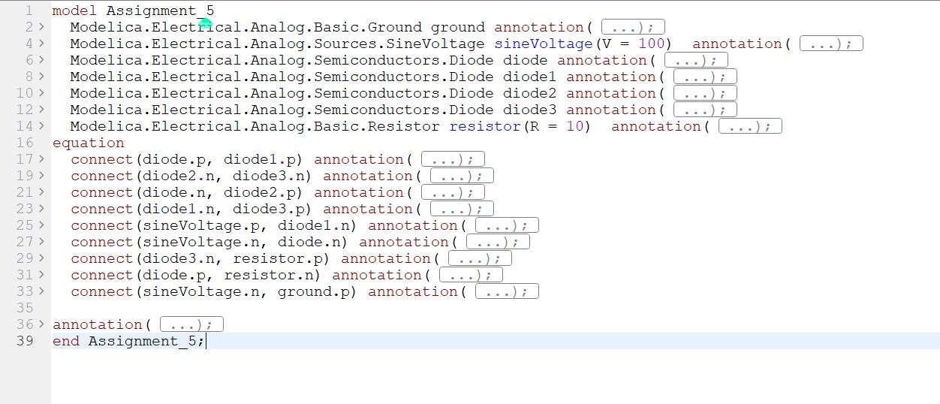

Step 6:after the compilation it will show you a plotting area where you have to plot, as per your given data you have to simulate.

